Food & Pests
Agriculture: 77% of world’s food comes from crops (wheat, rice, corn), 16% livestock, 7% from ocean
-Traditional Subsidence Farming: makes enough food for family’s survival (LOW INPUT)
-Industrial Farming: in developed countries… major source of air pollution! (HIGH INPUT)
*Green Revolution (after the industrial revolution): use of machinery, expanded irrigation, increase in fertilizers/pesticides, and development of high-yield seeds led to improvements in agriculture.
Fertilizer (N, P, K)
-Inorganic: Low cost, but not long lasting
-require large amounts of energy to produce, reduce quality of soil, runoff pollution into water supply (cultural eutrophication!)
-Organic: Higher cost, but longer lasting
Pesticides: -helps reduce the number of crops lost to insects, fungi, and pests. Affective against spread of disease
-Broad-Spectrum: works on many pests
-Narrow-Spectrum: works on a specific pest
-Downsides
- evolution… pests adapt to exposure and pesticides are no longer effective! … need to develop new pesticides/increase dosage… PESTICIDE TREADMILL.
-pollutants! Organophosphates! Chlorinated hydrocarbons (DDT)! POPs! Are persistant and biomagnified! (FIFRA, Stockholm Convention on POPs)
-Solution: INTEGRATED PEST MANAGEMENT:
-uses a combination of chemical pesticides, introduction of biological predators, cultivation methods (intercropping), etc, to keep the pest population down to an economically viable level.

Environmental Effects of Agriculture:
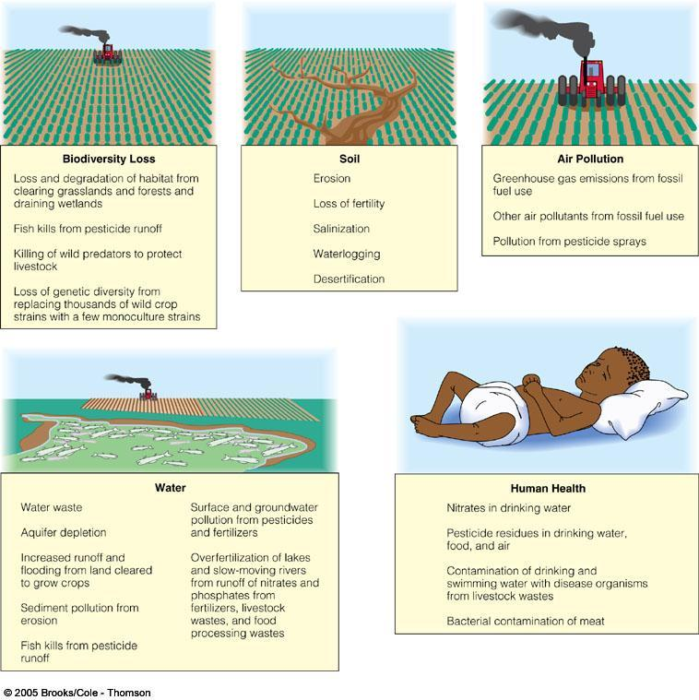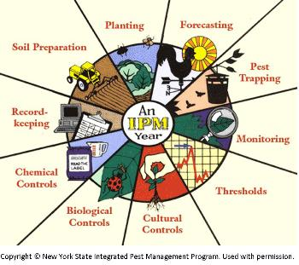
Genetically Modified Organisms & Selective Breeding of Specfic Crop Plants = MORE FOOD
-Loss of biodiversity! increase in pests (evolution!)

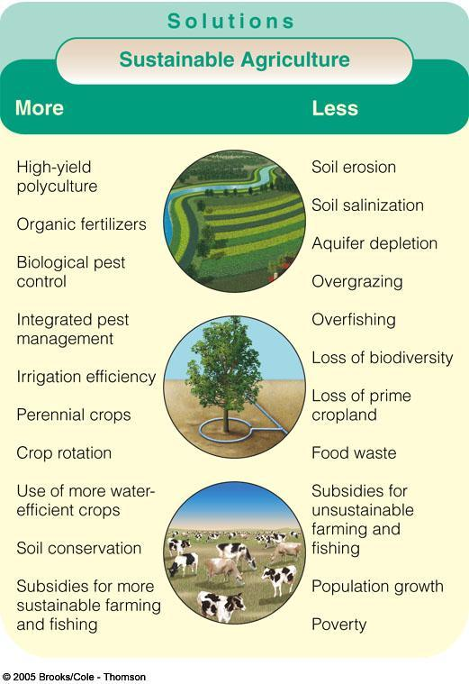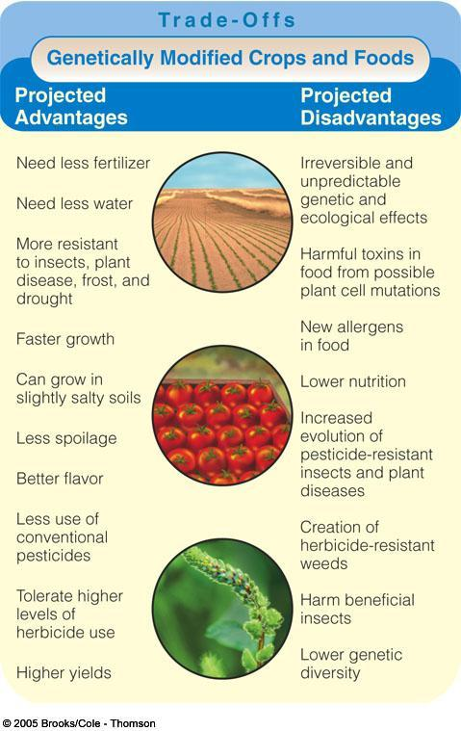
Livestock (mainly in developed countries)
Problems with Rangeland Farming:
Large factory production (GHGs), animal waste in water supply (eutrophication!), stress on world’s grain/water supply to sustain, methane production, overgrazing (erosion)/deforestation
Ocean Resources
Fishing
-Concerns: overfishing leads to extinction/loss of biodiversity; bycatch; destruction of habitiats. KNOW DIFFERENT TYPES OF FISHING METHODS.
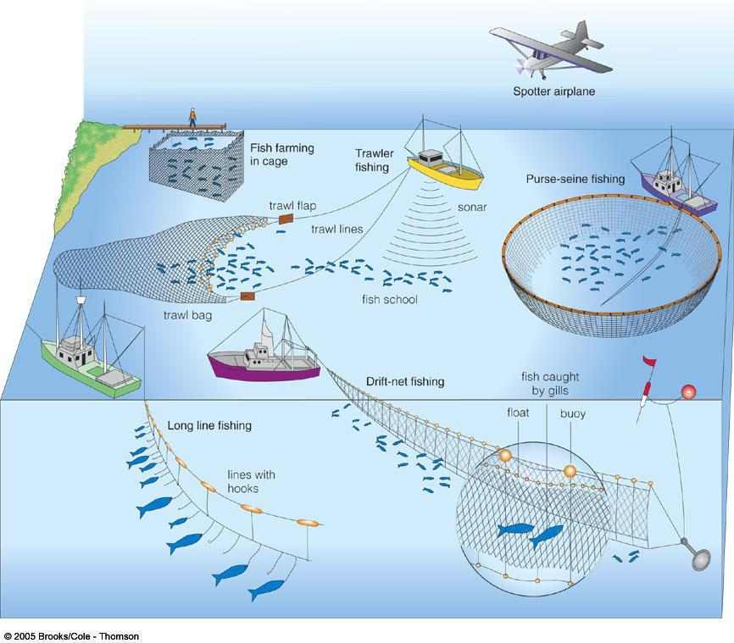
Fish Farming
-Concerns: dense monocultures vulnerable to disease!, concentrated waste output, loss of biodiversity, use of energy

