Ecology
Organism Population Community Ecosystem Biosphere
Terrestrial Biomes: Categorized by Temperature and Precipitation.
Aquatic Biomes: Categorized by Temperature and Salinity
* KNOW ALL TERRESTRIAL AND AQUATIC BIOMES AND UNIQUE CHARACTERISITICS/ANIMAL ADAPTATIONS
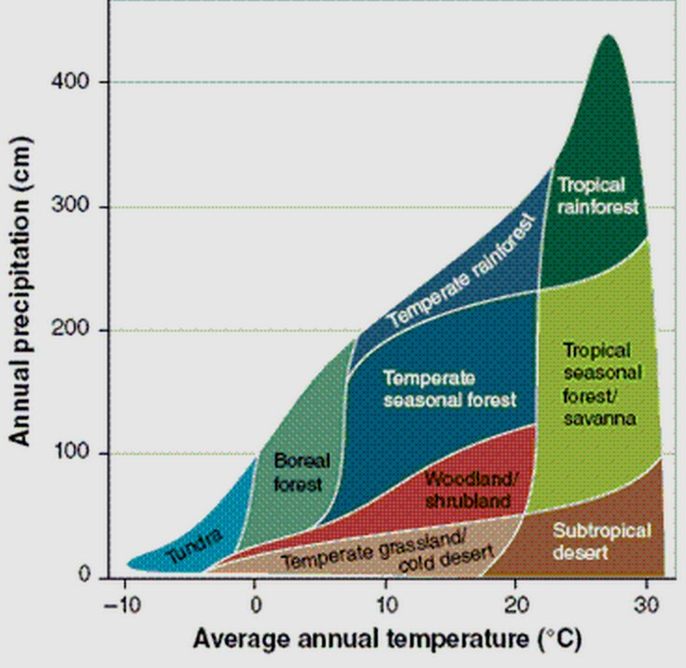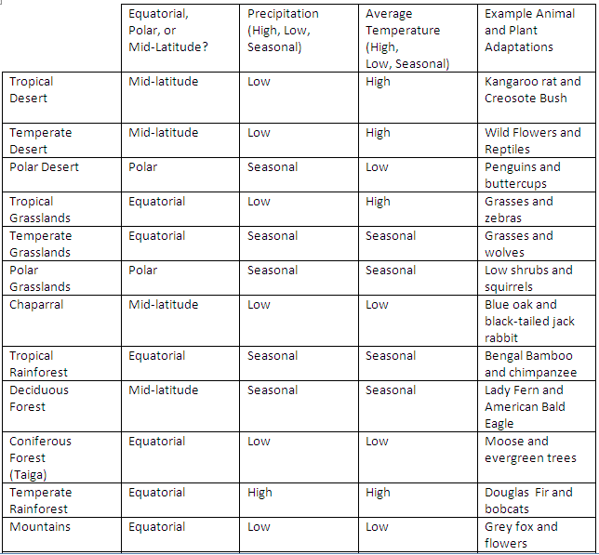
Ecotone: where two biomes meet; Ecoregion: small region within a biome that has distinct features
Biodiversity within an ecosystem is a GOOD THING… a measure of ecosystem health!!!

Food Chains/Webs and Energy Flow
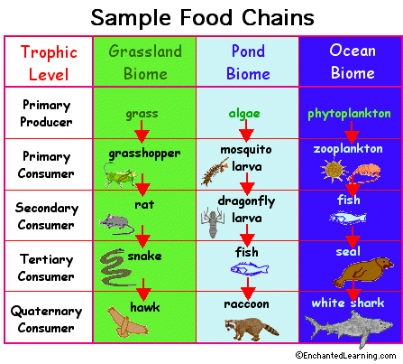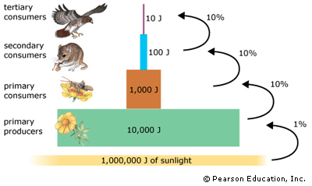
Pyramid of Energy: 10% of energy is passed on from one trophic level to the next (90% lost as HEAT!)
-results in Pyramid of Biomass & Pyramid of Numbers
Producers: autotrophs (create own energy with photosynthesis!)
Net Primary Productivity = Gross Primary Productivity – plant cell respiration
Consumers: heterotrophs (EAT to get energy)
Detritivores: Consume non-living organic matter (dead animals, plant litter)
Decomposers: bacteria and fungi that absorb nutrients from nonliving organic matter. Recycle materials back into inorganic forms.
Bioaccumulation: accumulation of a substance in the body tissue of an organism (ONE organism)
Biomagnification: the increase in concentration of toxins in higher trophic levels. (UP the FOOD CHAIN)
Evolution:
-Natural selection and speciation… individuals best fit for their environment are more likely to reproduce. Evolution requires MANY generations!
-Extinction
-Ecological vs. economic vs. biological
-r-selected vs. k-selected species
Relationships between species
-Niche (realized (actual) vs. fundamental (ideal)): how a species uses the resources in its environment. No two species can occupy the same niche!
-Resource partitioning and competition (intraspecific (same species) vs. interspecific (diff species))
-Predation
-Symbiotic Relationships (Mutualism, Commensalism, Parasitism)
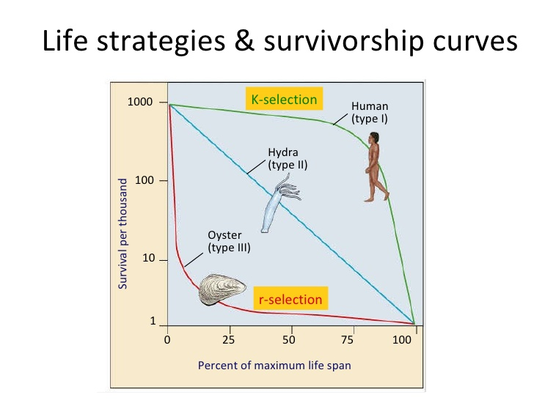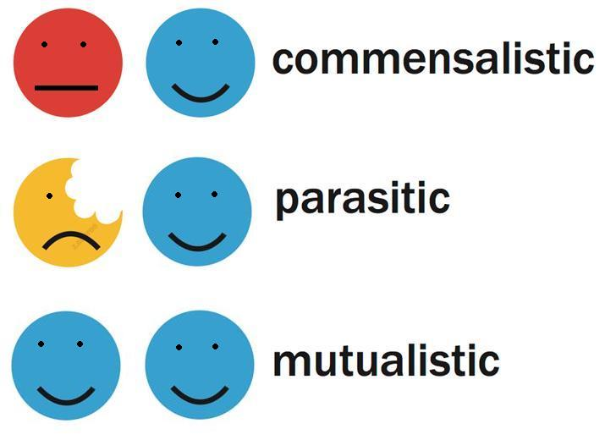
How ecosystems change
-Keystone species: a species whose presence contributes to an ecosystem’s diversity and whose extinction would lead to extinction of other species. VERY IMPORTANT ROLE in the ecosystem
-Indicator species: a species that is used to evaluate the HEALTH of an ecosystem
-Indigenous (native) vs. Invasive/Alien (not native)
-Generalist (can live in many environments; invasive species!) vs. Specialist (specific environment)
Ecological Succession
-Primary Succession: where an ecosystem begins in a lifeless area (NO SOIL)
-Secondary Succession: forms after a fire, tornado, human impact, other disaster (SOIL IS STILL INTACT)
