Climate Change & Greenhouse Gases
Climatic Temperature trends on Earth: know how these are related to feedback loops!
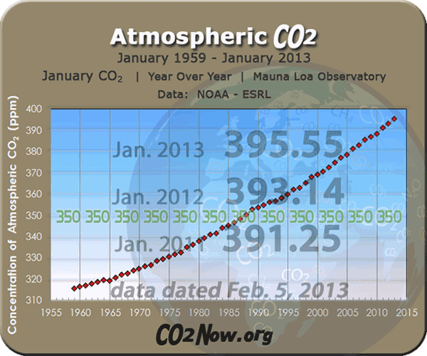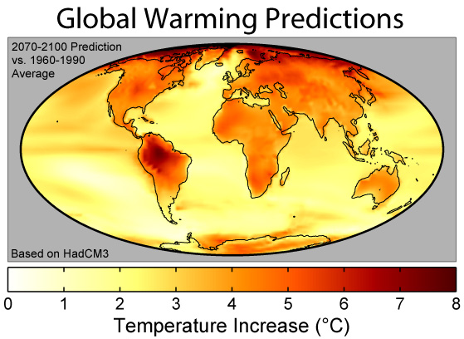

GLOBAL WARMING
Greenhouse Gases: Absorbs UV and Infared Lights from the surface… TRAPPED IN TROPOSPHERE
- H₂O: in form of water vapor
- CO₂: mostly from fossil fuel use in electricity and transportation, deforestation *MOST IMPORTANT
- Methane(CH₄): Landfills, cattle, rice paddies, fossil fuel use, wetlands
- N₂O: Fertilizer, cars, deforestation
- CFCs: only anthropgenic GHG; depletes ozone layer; foams, aerosols, refrigerants, solvents (Montreal P)

Other tropospheric temperature mediators:
-Clouds; can warm (absorb in troposphere) or cool (reflect back to space)
-Particulates: ash, sand, dust
-Increase cloud coverage
-has high albedo, so can cool during the day, BUT at night it is warmer because heat can be radiated back into space
- Albedo:
-Snow/Ice: heat is reflected
-No snow/Ice: heat is absorbed

Impacts of Global Warming
-rises in seal level- why? What will this lead to?
-melting of permafrost – why is this bad?
-agricultural shifts/crop yields
-more diseases- increase in storms and more hot days
-Ocean acidification- leads to shells degrading, coral bleaching

What can we do to reduce the threat of global warming?
-Improve energy efficiency – know how!
-Store carbon dioxide –Review Carbon cycle
-Plant more trees, sequestration (capture, compress, inject), inject in deep ocean
-Reduce GH gases: methane, CFCs , CO2
-GH gas emissions trading program
-Montreal Protocol- eliminate CFCs to strop ozone layer depletion
-Kyoto protocol – reduce GHG emissions (Why did we withdraw?)
-Paris Climate Change Treaty

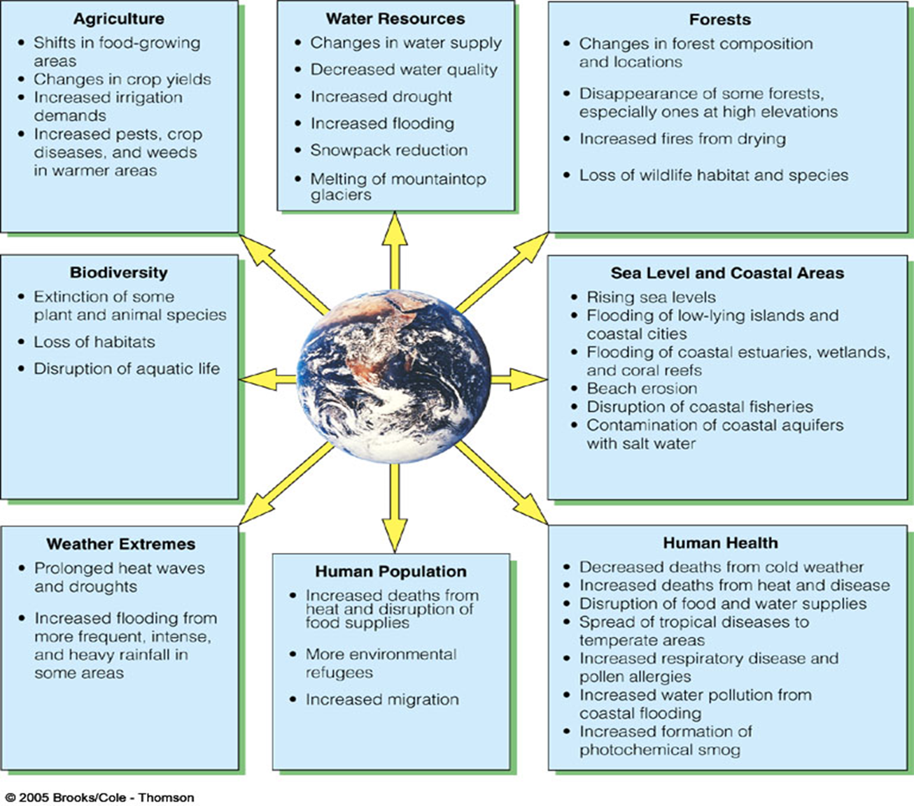
Ozone Layer Depletion in Stratosphere
Ozone is found naturally in the stratosphere! GOOD in stratosphere! (BAD in troposphere!)
Ozone Layer: absorbs UV rays from sun… GOOD
-is destroyed by reacting with Cl-, F-, and Br- (from CFCs!)
-“hole” in Antarctica

-UV-A vs. UV-B vs UV-C
-Effects of UV radiation: skin cancer, impact crops/animals, changes in weather patterns, increased ground-level smog, increased rate of DNA mutations, inhibited photosynthesis of plants.

